**Main Points**

Recall your ideal city

Traffic Flow is an explicitly function of only follow distance

Average Speed affected by physics.

Supply and Demand Lessons

**Introduce New Topics**

Safety of light rail.

Trackless tram

LP Main Objectives

Incentive your idea vs what they already have

**LP Lesson**

Make $2 per bushel of apples $4 per bushel of mangos

Have a truck that can take 100 bushels of either fruit to market

Have space for up to 120 apples on your land or a total of 72 mangos

Max profit 2A + 3M

A+M <= 100

3A+5M <= 360

Objective – max profit

Decision Variables – how many bushels of apples or mangos to grow

Parameters – total amount of bushels that you can grow, how much space you land has

Answer: 70 A; 30 M

Sensitivity Analysis

What happens if you make $4/ mango

72 M

Or if you only have space for 80

20 A, 60 M

Or if you only grow 100 apples and 60 mangos

100 A

More or less parking

Gas $2 / gal; 24 miles/gal

Maintenance: $0.05/ mile

Time: 30 mph normal; 20 mph traffic times

Average distance to work: 15 miles

Work: 20 times a month

Worth of time: $5/hour

Discount factor to current decision: 0.90

**The actual model**

Baseline: 600 miles to work every month. 25 gallons every month. Time 30 hours in car.

$50 for gas, $30 for maintenance, $150 for time.

$230 and any alternative would have to be $207 or cheaper to be accepted if nothing changed.

Citizens are willing to pay $280 max for transportation, anything more riots. Anything less they will throw a benevolent dictator day.

Case Study

Assume your bus is $3 round trip. Average speed 20 miles per hour.

$60 for trips. 30 hours on bus. $150 for time. $210 total not low enough for citizens to want to switch.

But what if you started charging $2 for parking as well. Then their cost would be $270 for their normal method. And $270 * .9 = $243 which is more than the bus cost. So you have an option below the riot cost and the citizens would pick your option before theres.

Need your cost in time and cost per mile.

**Next Subject**

Jeopardy – Planet Texas

**Closer to Monopoly / Try to control portions of light**

Game give each team 1 card from each of these sectors. You split the revenue evenly between each card.

However, once you have 3 of a light source you get 90% of the revenue and the remaining card only gets 10%.

Cell phone companies need to put $10 million in telecom infrastructure.

Nuclear Plants need to put $5 million in waste. Unless you own the waste.

All other tech is stand alone.

Can Use a Deck of Cards. In fact its easier to use cards.

Keep Score on the Board.

Do a round where you don’t tell the students the revenue of each sector.

Do a quiz to determine the two groups who get the waste management and telecommunication infrastructure cards.

I.e. place different types of light on the appropriate part of the spectrum

This forces the teams to trade otherwise the team who received telecommunication infrastructure would win (note still don’t tell them how much that is worth.)

Give the teams about 10 mins to trade.

Repeat game after telling each team how much each sector is worth. See if the strategy changes.

|  |  |  |  |  |
| --- | --- | --- | --- | --- |
| Light | Game Revenue | 1 Card | 3 Cards (90%) | 1 Card (10%) |
| Cell Phone (2) | $160 | $40 | $144 | $16 |
| Nuclear Power Plant (3) | $80 | $20 | $72 | $8 |
| X-Ray/CT Scans (4) | $60 | $15 | $54 | $6 |
| Broadcast TV (5) | $40 | $10 | $36 | $4 |
| WiFi / RFID / IOT (6) | $40 | $10 | $36 | $4 |
| 5G (7) | $30 | $8 | $27 | $3 |
| GPS (8) | $25 | $6 | $22.5 | $2.5 |
| Telecom. Infrastructure (Jack) | $25 | $25 | N/A | N/A |
| AM/FM Radio (9) | $20 | $5 | $18 | $2 |
| Nuclear Medicine (10) | $20 | $5 | $18 | $2 |
| Nuclear Waste Mgmt. (Ace) | $10 | $10 | N/A | N/A |

c= lambda*f

E = h * f = h * c / lambda

**Sources**

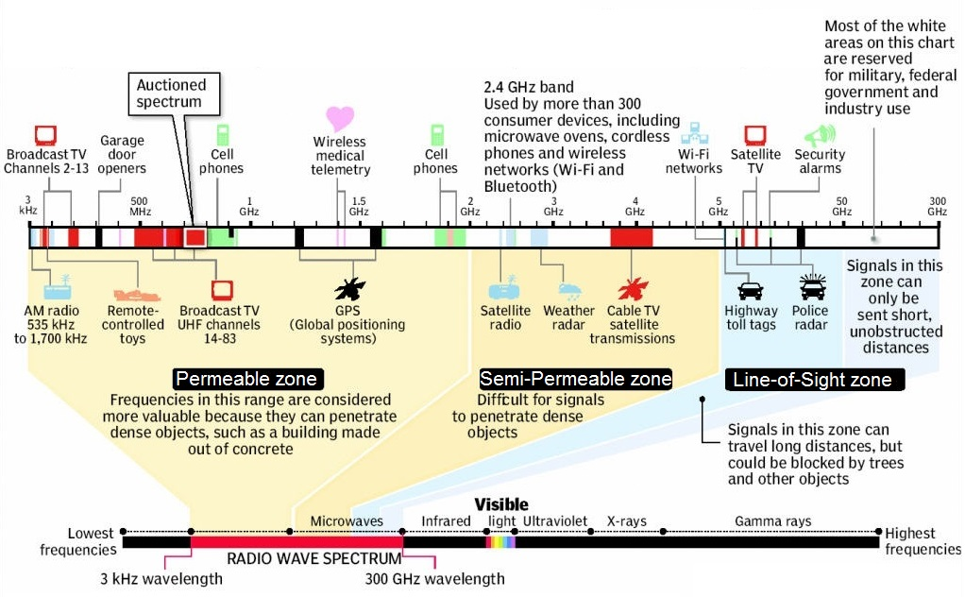

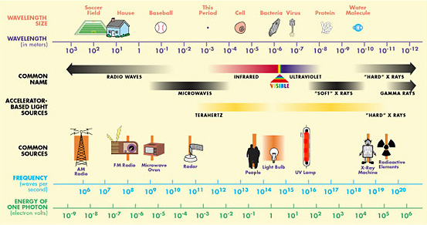

AM Radio / FM Radio ($22 billion)

<http://www.insideradio.com/free/radio-s-streaming-ad-revenue-to-hit-billion-by/article_db9ff3f2-6959-11e8-b7d0-ab466f7bba4d.html>

Broadcast Television ($40 billion)

<https://www.broadcastingcable.com/news/tv-revenue-expected-to-dip-in-record-setting-year-for-ads>

Cell Phone ($200 billion)

<https://cbpp.georgetown.edu/sites/default/files/Policy%20Paper%20-%20Kovacs%20-%20Wireless%20Competition%202018-08.pdf>

GPS ($25 billion)

<https://www.businesswire.com/news/home/20161018006653/en/Global-GPS-Market-2016-2022-Market-Generated-Revenue>

RFID technology ($13 billion)

<https://www.reportlinker.com/p05503702/Radio-Frequency-Identification-Market-Revenue-to-Grow-at-a-CAGR-of-14-5-During-Driven-by-Integrating-RFID-Technology-with-IoT-and-Big-Data-Platforms-for-Real-time-Data-Access.html>

5G signals ($30 billion)

<https://telecom.economictimes.indiatimes.com/news/5g-to-generate-usd-27-3-bn-revenue-potential-by-2026/61689424>

X-Rays / CAT Scan ($56 billion)

https://www.grandviewresearch.com/press-release/medical-imaging-systems

Nuclear Medicine (gamma rays) ($15.2 billion)

<https://www.grandviewresearch.com/press-release/global-nuclear-medicines-market>

<https://www.mapw.org.au/files/downloads/Nuclear%20medicine%20fact%20sheet.pdf>

Nuclear Power Plant (gamma rays) ($80 billion) (805 billion kWh)

<http://www.world-nuclear.org/information-library/country-profiles/countries-t-z/usa-nuclear-power.aspx>

Nuclear Waste Management ($6 billion)

<https://www.prnewswire.com/news-releases/nuclear-waste-management-market-to-account-for-us563-billion-in-revenue-by-2024-influx-of-investments-to-support-growth-tmr-580244921.html>

Telecommunications Infrastructure ($25 billion)

**What Waves can kill you hot potato type game: Like a land domination game. Give other groups your radiation with some type of credit or clear your own radiation. Time and dice based.**

Higher energy waves can kill you with high dice rolls 4-6.

Medium energy waves can kill you with medium dice rolls 2 and 3

Low energy waves can kill you only with a 1.

However, the kill roll only works after you have the card for 1 turn for high energy, 2 turns for medium energy, and 3 turns for low energy.

Each group starts with one of each. And can trade with other groups. But every turn you have to give and receive a type of energy from each group.

Needs a proper physics introduction why these waves are dangerous.

*Looking for a proper physics feel to this.*

*Last game was too much “economics”*

Bring people into it

All part of the same thing change the wavelengths or frequencies.

How did they figure it out Maxwell, Einstein give humanity to the equations?

Play with different frequencies f

Some of the divisions of light are determined by nature others are determined by society i.e. visible light vs. military spectrum

UV comes in infrared comes off what happens to the energy (carbon absorbs the energy)

Draw the waves of light

Fill in the light spectrum

Amplitutde gives data

Why the sun’s light can go in but not out?

The light coming out of your lights is the same as your cell phone signal

Terraforming Competition

You are humans from the future whose groups are charged with terraforming various planets.

As you have learned in your various advanced science classes CO2 concentration has a strong effect on life and biodiversity of your planets. Rather than trying to win the evolution jackpot you seek to control your GHG concentration. However, you peers are doing the same thing. The only solution is sabotage.

**Setup/Background**

The game consists of 3 rounds with 4 turns in each round. It goes in a snake like order i.e. the first team goes first in the first round and last in the second round.

You start with chips worth 30 CO2 concentration >>> 300 ppm. You start with 3 blue chips (5 points a piece can’t be traded), 4 red chips (worth 2 points a piece can be traded), and 7 white chips (worth 1 point a piece can be traded). You will receive 5 points for GHG in range 20-25, 4 points for 25-30, 3 points for 30-35, 2 points for 35-40, and 1 point for anything higher than 40. You score each team at the end of each round.

**In your turn**

You can convert exactly 5 CO2 points (white and red chips only) for a blue chip to stabilize the carbon on your planet also removing the CO2 from the game.

You can send up to 9 CO2 points to any team.

Note you do not have to trade or convert.

**Special Case**

In round 3 you can turn give the accountant 4 blue chips and get 3 blue chips in return.

**Summary**

That’s it. You have 4 turns to trade around tradable CO2 or convert it to blue chips. You keep score at the end of each round. Thus you will have three scores to add up at the end. You do not reset at the end of each round.

**Final City Building**

3 types of Currency (Capital, Labor, Materials)

Can build anything with some combination of those things.

4 Types of Cities

Capital Intensive (12 coins)

Labor Intensive (12 coins)

Material Intensive (12 coins)

Balanced ( 4 of each)

Can trade amongst each other.

Can create you own plans as long as I can implement them in my program.

Benefits can be stacked.

Some examples

Roads (2 capital, 2 labor, 2 material)

-lowers travel cost by 15%

Train (3 capital, 3 labor, 3 material)

-lowers travel cost by 10%

-lowers emissions by 10%

Tax Cuts (2 capital)

-Increases income by 15%

Parks ( 2 labor, 1 capital)

-raises amenity by 10%

Stadium ( 2 labor, 2 capital, 2 material)

-raises amenity level by 25%

Electric Vehicle Subsidy (4 capital)

-lowers emissions by 15%